# SOP on Aaochat

# Table of Contents

Contents

SOP on Aaochat 1

Table of Contents 2

Steps to create pipeline for Aaochat-Business-Master 4

Step 1: Create a Job 4

Step 2: Choose Freestyle Project 4

Step 3: Configure the Project 4

Step 4: Add Project URL: 4

step 5: Restrict where this project can be run 4

Step 6: Add Source Code Management 4

Step 7: Add Branch: 4

Step 8: Build Triggers: 4

Step 9: Build Environment: 4

Step 11: Add Execute Command 5

Step 12: Provide Node & npm bin/ folder to Path 5

**Aaochat Business Master**

**AIM:**

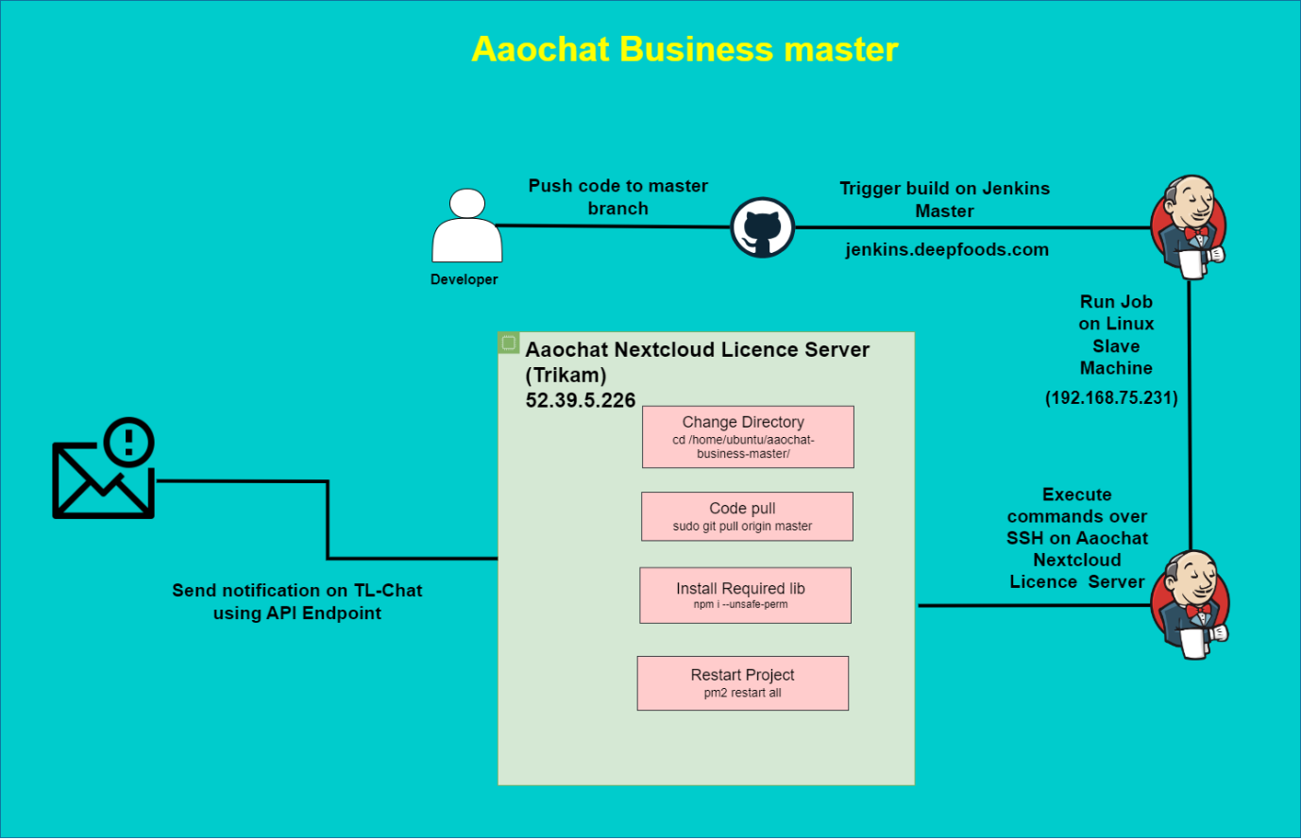

Figure 1: Artichecture of Aaochat Business Master.

**Prerequisites**:

Git URL

SSH Server

NodeJS

**Navigate to Jenkins**

jenkins.deepfoods.com

# Steps to create pipeline for Aaochat-Business-Master

### Step 1: Create a Job

On the Jenkins dashboard, click on 'New Item' at the left top side of the dashboard.

### Step 2: Choose Freestyle Project

Enter a name under 'Enter an item name'. Then select 'Freestyle project' and click on 'OK'.

### Step 3: Configure the Project

There are many configurations we can do: -

General: Here you can set the project name, description, and other settings.

### Step 4: Add Project URL:

<https://github.com/aaochat/aaochat-business-master.git/>

### step 5: Restrict where this project can be run

Label Expression: Linux_Slave

### Step 6: Add Source Code Management

Git: Add Repository URL and Credentials

### Step 7: Add Branch:

*/master

### Step 8: Build Triggers:

Github hook trigger for GITScm polling

### Step 9: Build Environment:

Send files or execute commands over SSH after the build runs

Add SSH

from Manage Jenkins > System>

Aaochat Nextcloud License Server

Provide below information to add SSH

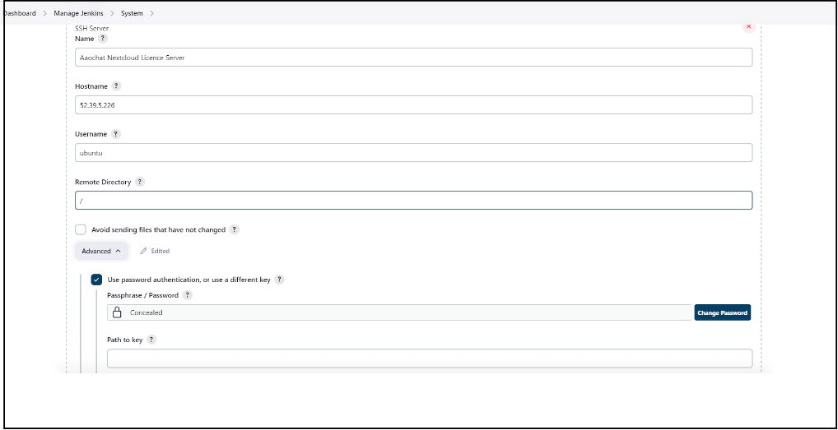

Figure 2: Add SSH in Manage Jenkins.

Step 10: Once you've added the SSH Server scroll to the bottom of the page and click Apply, then Save.

### Step 11: Add Execute Command

* cd /home/ubuntu/aaochat-business-master/
* sudo git pull origin master
* npm i --unsafe-perm
* pm2 restart all

**Purpose of above commands**

#sudo git pull origin master:

Contact the remote repository specified as "origin."

Fetch any new changes (commits) from the "master" branch on the remote repository.

Merge those changes into your currently checked-out branch (in this case, "master").

#npm i --unsafe-perm:

This command uses npm to install packages and dependencies for your Node.js project.

#pm2 restart all:

is used with PM2, a process manager for Node.js applications, to restart all processes managed by PM2

### Step 12: Provide Node & npm bin/ folder to Path

* Add Nodejs from Manage Jenkins > Tool>
* Provide below information to add NodeJS
* Provide NodeJS 16.20.0

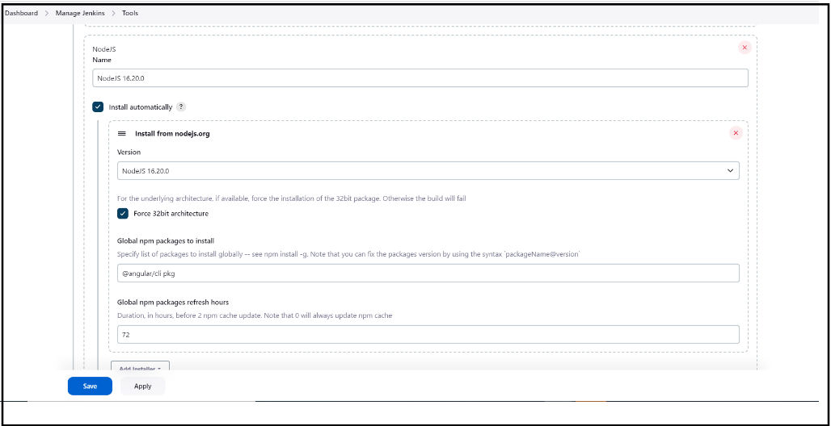

Figure 3: Add NodeJS in Manage Jenkins.

Step 13: Once you've added the NodeJS you want, scroll to the bottom of the page and click Apply, then Save.

Step 14: Once connected you can Apply and Save the